Course Project Report on
“Supply Chain Management System”
SUBMITTED IN PARTIAL FULFILLMENT OF THE REQUIREMENTS FOR THE DEGREE OF
BACHELOR OF TECHNOLOGY
IN
“Computer Science and Engineering (Artificial Intelligence)”

OF
VISHWAKARMA INSTITUTE OF TECHNOLOGY

Subject Name

Sahil Patil (12412097)
Sanskar Petkar (12411562)
Sarthak Patkar (12410783)
Hriddhi Srivastav (12412284)
Raghav Mishra (12414990)

UNDER THE GUIDANCE OF
“Prof. Sandip Bobade”

Computer Science and Engineering
(Artificial Intelligence)

BANSILAL RAMNATH AGARWAL CHARITABLE TRUST’S
VISHWAKARMA INSTITUTE OF TECHNOLOGY
(An Autonomous Institute affiliated to Savitribai Phule Pune University)

2025- 2026
BANSILAL RAMNATH AGARWAL CHARITABLE TRUST’S

VISHWAKARMA INSTITUTE OF TECHNOLOGY
(An Autonomous Institute affiliated to Savitribai Phule Pune University)

PUNE – 411037


CERTIFICATE

This is to certify that the Course Project titled “Supply Chain Management System” submitted by Hriddhi Srivastav (12412284), Sahil Patil (12412097), Sarthak Patkar (12410783), Sanskar Petkar(12411562), Raghav Mishra (12414990), is in partial fulfillment for the award of Degree of Bachelor of Technology in Computer Science and Artificial Intelligence of Vishwakarma Institute of Technology, Savitribai Phule Pune University. This project report is a record of Bonafide work carried out by him under my guidance during the academic year 2025-26.

Guide HOD, CSAI
Prof. Sandip Bobade Prof. Nilesh Sable

Place: VIT, Pune
Date: 12 November 2025

Bansilal Ramnath Agarwal Charitable Trust’s

Vishwakarma Institute of Technology, Pune-37
Department of Computer Science and Artificial Intelligence

PROJECT SYNOPSIS

Group No: 2
Members: 5
Roll No. | PRN | Name of Student | Contact No. | Email ID
3 | 12412284 | Hriddhi Srivastav | 85914 30714 | hriddhi.srivastav24@vit.edu
8 | 12412097 | Sahil Patil | 9834383919 | sahil.patil24@vit.edu
13 | 12410783 | Sarthak Patkar | 7721905736 | sarthak.patkar24@vit.edu
17 | 12411562 | Sanskar Petkar | 7420026974 | sanskar.petkar24@vit.edu
25 | 12414990 | Raghav Mishra | 9156527644 | raghav.mishra24@vit.edu

Academic Year : 2025-2026
Project Title : Supply Chain Management System
Project Area : Software Development & Programming
Internal Guide : Prof. Sandip Bobade

Signature of Internal Guide

i

Acknowledgement

We would like to express our deep sense of gratitude to Prof. Sandeep Bobade, our project guide, for his valuable guidance, continuous support, and encouragement throughout the development of our project “Supply Chain Management System.” His insightful suggestions, technical expertise, and constant motivation have been instrumental in successfully completing this work.

We are also sincerely thankful to Dr. Nilesh P. Sable, Head of the Department of Computer Science and Engineering (Artificial Intelligence), for his continuous guidance, encouragement, and for providing us with the facilities and environment needed to carry out this project effectively.

Our heartfelt thanks go to all the faculty members of the Department of Computer Science and Engineering (AI) for their valuable advice and constant inspiration during this project journey. We would also like to express our gratitude to Vishwakarma Institute of Technology, Pune, for providing the necessary infrastructure, resources, and support that made this project possible. Lastly, we extend our sincere thanks to our friends, classmates, and family members for their continuous cooperation, motivation, and moral support throughout the course of this project.

ii
ABSTRACT

The Supply Chain Management System is a Java-based project designed to streamline and digitalize the interaction between suppliers and consumers. The main objective of this system is to provide an efficient platform for managing product details, supplier information, and consumer orders in an organized and automated manner.

The system allows suppliers to register, log in, add new products, and view their existing product lists. On the other hand, consumers can register, log in, browse available products, and place orders based on their requirements. All the data generated through these operations is securely stored and managed in a MySQL database, which ensures real-time data access, consistency, and accuracy.
This project integrates Java programming concepts, Object-Oriented Programming (OOP), and Database Management System (DBMS) principles through the use of JDBC (Java Database Connectivity) for communication between the application and the database. The overall system provides a simple, reliable, and effective solution for managing supply chain activities while reducing manual effort and chances of human error.

The project successfully demonstrates how software technologies can be used to automate business processes, improve data management, and enhance the efficiency of supply chain operations.

iii
Table of Contents
Page no.
SYNOPSYS i
ACKNOWLEDGEMENT ii
ABSTRACT iii
TABLE OF CONTENTS iv
TABLE OF FIGURES v
CHAPTER-1: INTRODUCTION
 | 1.1 |  | Introduction 1
CHAPTER-2: SYSTEM ANALYSIS AND DESIGN
2.1 Project Design Diagram 2

CHAPTER-3: IMPLEMENTATION
. |  | 3.1 | Code of main Modules Used in Project 4
CHAPTER-4: OUTPUT
 |  | 4.1 | Screenshots of result 11
 |  | 4.2 | Outcome 12  .
CHAPTER-5: CONCLUSION
 |  | 5.1 | Conclusion 13
CHAPTER-4: OUTPUT
6.1 References |  |  |  | 14

iv

Table of Figures

Fig. No. | Name of Figure | Page No.
1.1 | Project Design Diagram | 2
1.2 | Mysql Database Integration | 3
v

1. Introduction
1

The Supply Chain Management System is a Java-based application developed to streamline the interaction between suppliers and consumers within a simplified digital environment. The system enables suppliers to register, log in, and manage their products, while consumers can register, log in, search for available products, and place orders directly through the application.
In today’s fast-paced business world, managing supply chains efficiently is critical for ensuring smooth operations, reducing costs, and maintaining customer satisfaction. Traditional methods often involve manual record-keeping and communication, which can lead to inefficiencies, errors, and delays. This project aims to automate these processes by providing a centralized database and a straightforward interface for both suppliers and consumers.
The application uses Java for implementation and MySQL as the database to ensure reliability, security, and data consistency. The system also utilizes JDBC (Java Database Connectivity) for communication between the application and the database. Through this project, users can experience a simple, command-line based system that demonstrates core functionalities such as registration, authentication, product management, and basic order handling.
This project serves as a foundational model for understanding how digital supply chain systems operate. Although it is limited in scope, it effectively highlights the key operations of inventory management, supplier-consumer coordination, and database interaction within a supply chain framework.

2.Project Design Diagram
2

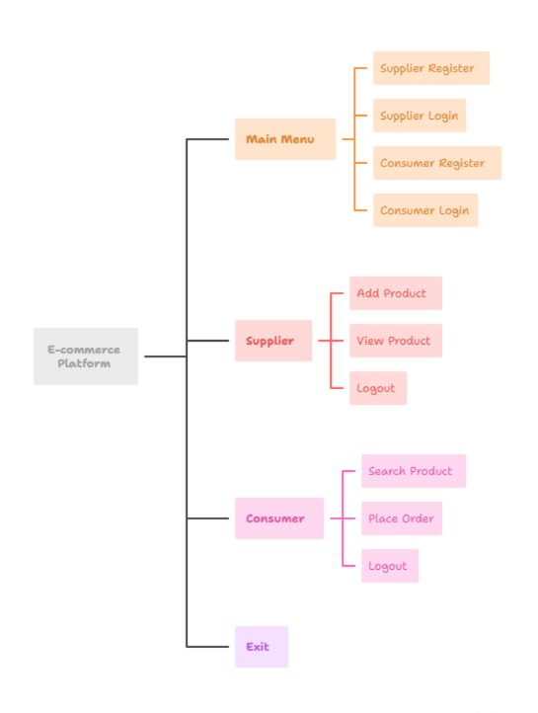
Fig.1.1 Project Design Diagram
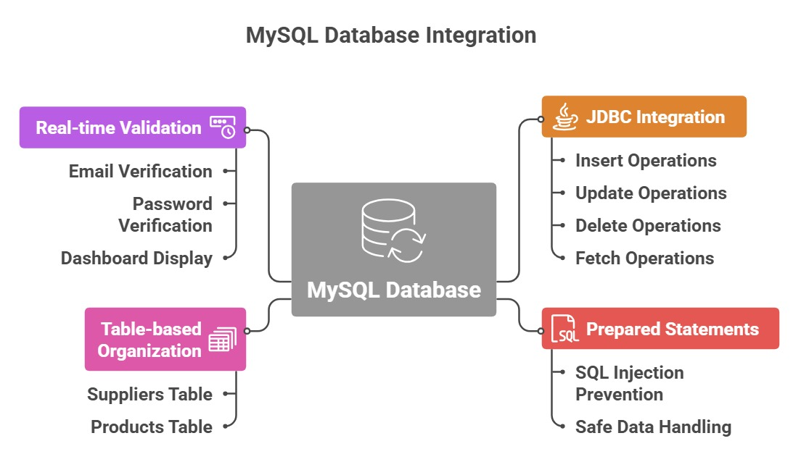
3

Fig.1.2 Mysql Database Integration

3.Codes of main modules used in project
4

#Main.java

import java.util.InputMismatchException;
import java.util.Scanner;

public class Main {
public static void main(String[] args) throws InputMismatchException{
Scanner sc = new Scanner(System.in);
SupplierService supplier = new SupplierService();
ConsumerService consumer = new ConsumerService();
int choice;

while (true) {
System.out.println("\n===== SUPPLY CHAIN MANAGEMENT SYSTEM =====");
System.out.println("1. Supplier Register");
System.out.println("2. Supplier Login");
System.out.println("3. Consumer Register");
System.out.println("4. Consumer Login");
System.out.println("5. Exit");
System.out.print("Choose: ");
choice = sc.nextInt();

if (choice == 1) {
supplier.register();
} else if (choice == 2) {
int id = supplier.login();
if (id != -1) {
while (true) {
System.out.println("\n1. Add Product");
System.out.println("2. View All Products");
System.out.println("3. Logout");
int ch = sc.nextInt();
if (ch == 1) supplier.addProduct(id);
else if (ch == 2) supplier.viewProducts(id);
else break;
}
}
} else if (choice == 3) {
consumer.register();
} else if (choice == 4) {
int id = consumer.login();
if (id != -1) {
while (true) {
System.out.println("\n1. Search Product");
System.out.println("2. Logout");
int ch = sc.nextInt();
if (ch == 1) consumer.searchAndOrder(id);
else break;
5
}
}
} else {
System.out.println("Thank you!");
break;
}
}
}
}

# DBConnection.java

import java.sql.Connection;
import java.sql.DriverManager;

public class DBConnection {
public static Connection getConnection() {
Connection con = null;
try {
Class.forName("com.mysql.cj.jdbc.Driver");
con = DriverManager.getConnection(
"jdbc:mysql://localhost:3306/supply_chain",
"Sahil",
"Sahil@123"
);
} catch (Exception e) {
System.out.println("Database Error: " + e);
}
return con;
}
}

# SupplierService.java

import java.sql.*;
import java.util.Scanner;

public class SupplierService {
Scanner sc = new Scanner(System.in);

public int register() {
System.out.print("Enter Email: ");
String email = sc.next();
System.out.print("Enter Password: ");
String password = sc.next();

try (Connection conn = DBConnection.getConnection()) {
6
PreparedStatement ps = conn.prepareStatement("INSERT INTO suppliers(email,password) VALUES(?,?)");
ps.setString(1, email);
ps.setString(2, password);
ps.executeUpdate();
System.out.println("Supplier registered successfully!");
} catch (Exception e) {
System.out.println("Registration Failed: " + e.getMessage());
}
return -1;
}

public int login() {
System.out.print("Enter Email: ");
String email = sc.next();
System.out.print("Enter Password: ");
String password = sc.next();

try (Connection conn = DBConnection.getConnection()) {
PreparedStatement ps = conn.prepareStatement(
"SELECT id FROM suppliers WHERE email=? AND password=?");
ps.setString(1, email);
ps.setString(2, password);
ResultSet rs = ps.executeQuery();

if (rs.next()) {
System.out.println("Supplier Login Successful");
return rs.getInt(1);
} else {
System.out.println("Invalid Email or Password");
}
} catch (Exception e) {
System.out.println("Login Error: " + e.getMessage());
}
return -1;
}

public void addProduct(int supplierId) {
System.out.print("Enter Product Name: ");
String name = sc.next();
System.out.print("Enter Quantity: ");
int qty = sc.nextInt();
System.out.print("Enter Location: ");
String location = sc.next();

try (Connection conn = DBConnection.getConnection()) {
PreparedStatement ps = conn.prepareStatement(
"INSERT INTO products(supplier_id,product_name,quantity,location) VALUES(?,?,?,?)");
ps.setInt(1, supplierId);
ps.setString(2, name);
ps.setInt(3, qty);
7
ps.setString(4, location);
ps.executeUpdate();
System.out.println("Product Added Successfully!");
} catch (Exception e) {
System.out.println("Error: " + e.getMessage());
}
}

public void viewProducts(int supplierId) {
try (Connection conn = DBConnection.getConnection()) {
PreparedStatement ps = conn.prepareStatement(
"SELECT * FROM products WHERE supplier_id=?");
ps.setInt(1, supplierId);
ResultSet rs = ps.executeQuery();

System.out.println("===== Your Products =====");
while (rs.next()) {
System.out.println(rs.getInt("id") + " | " +
rs.getString("product_name") + " | Qty: " +
rs.getInt("quantity") + " | Location: " +
rs.getString("location"));
}
} catch (Exception e) {
System.out.println("Error: " + e.getMessage());
}
}
}

# ConsumerService.java

import java.sql.*;
import java.util.Scanner;

public class ConsumerService {
Scanner sc = new Scanner(System.in);

public int register() {
System.out.print("Enter Email: ");
String email = sc.next();
System.out.print("Enter Password: ");
String password = sc.next();

try (Connection conn = DBConnection.getConnection()) {
PreparedStatement ps = conn.prepareStatement("INSERT INTO consumers(email,password) VALUES(?,?)");
ps.setString(1, email);
ps.setString(2, password);
ps.executeUpdate();
System.out.println("Consumer registered successfully!");
} catch (Exception e) {
8
System.out.println("Registration Failed: " + e.getMessage());
}
return -1;
}

public int login() {
System.out.print("Enter Email: ");
String email = sc.next();
System.out.print("Enter Password: ");
String password = sc.next();

try (Connection conn = DBConnection.getConnection()) {
PreparedStatement ps = conn.prepareStatement(
"SELECT id FROM consumers WHERE email=? AND password=?");
ps.setString(1, email);
ps.setString(2, password);
ResultSet rs = ps.executeQuery();

if (rs.next()) {
System.out.println("Consumer Login Successful");
return rs.getInt(1);
} else {
System.out.println("Invalid Email or Password");
}
} catch (Exception e) {
System.out.println("Login Error: " + e.getMessage());
}
return -1;
}

public void searchAndOrder(int consumerId) {
System.out.print("Enter Product Name: ");
String pname = sc.next();

try (Connection conn = DBConnection.getConnection()) {
PreparedStatement ps = conn.prepareStatement(
"SELECT * FROM products WHERE product_name=? AND quantity>0");
ps.setString(1, pname);
ResultSet rs = ps.executeQuery();

System.out.println("===== Available Suppliers =====");
while (rs.next()) {
System.out.println(rs.getInt("id") + " | Supplier: " +
rs.getInt("supplier_id") + " | Qty: " +
rs.getInt("quantity") + " | Location: " +
rs.getString("location"));
}

System.out.print("Select Product ID to Buy: ");
int pid = sc.nextInt();
9
System.out.print("Enter Your Location: ");
String loc = sc.next();

PreparedStatement check = conn.prepareStatement(
"SELECT quantity, location FROM products WHERE id=?");
check.setInt(1, pid);
ResultSet rs2 = check.executeQuery();

if (rs2.next()) {
String supplierLoc = rs2.getString("location");
int qty = rs2.getInt("quantity");

if (!supplierLoc.equalsIgnoreCase(loc)) {
System.out.println("Supplier does not ship to your location!");
return;
}

System.out.print("Enter Quantity: ");
int q = sc.nextInt();

if (q > qty) {
System.out.println("Not enough stock!");
return;
}

PreparedStatement update = conn.prepareStatement(
"UPDATE products SET quantity=quantity-? WHERE id=?");
update.setInt(1, q);
update.setInt(2, pid);
update.executeUpdate();

System.out.println("Order Placed Successfully!");
}

} catch (Exception e) {
System.out.println("Order Error: " + e.getMessage());
}
}
}

# MySQL Code
10

CREATE DATABASE supply_chain;
USE supply_chain;

CREATE TABLE suppliers (
id INT AUTO_INCREMENT PRIMARY KEY,
email VARCHAR(255) UNIQUE,
password VARCHAR(255)
);

CREATE TABLE consumers (
id INT AUTO_INCREMENT PRIMARY KEY,
email VARCHAR(255) UNIQUE,
password VARCHAR(255)
);

CREATE TABLE products (
id INT AUTO_INCREMENT PRIMARY KEY,
supplier_id INT,
product_name VARCHAR(255),
quantity INT,
location VARCHAR(255),
FOREIGN KEY (supplier_id) REFERENCES suppliers(id)
);

4.Screenshots of results
11

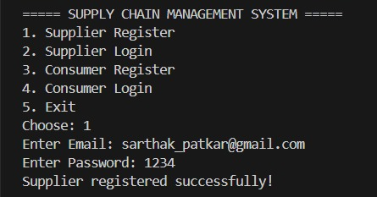
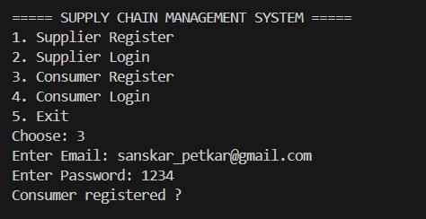

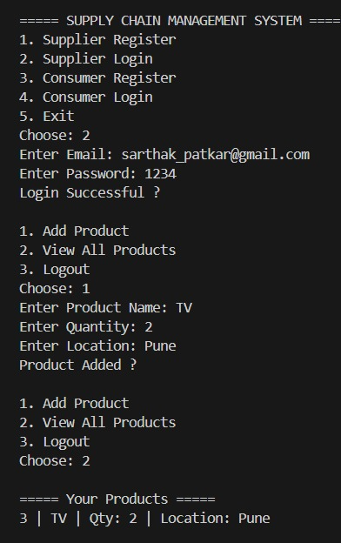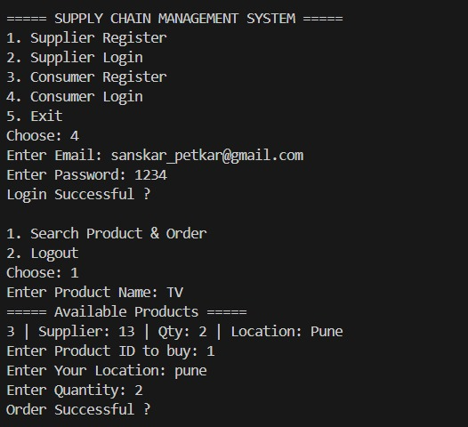

5.Outcome
12

The Supply Chain Management System successfully meets its primary goal of providing an automated platform for managing supplier and consumer interactions. The project outcome demonstrates how a database-driven application can efficiently handle core supply chain operations such as user registration, login authentication, product management, and order placement.

Through this project:
Suppliers can register, log in, and add or view their products. Consumers can register, log in, search for available products, and place orders based on product availability and location. The system effectively maintains data consistency using MySQL and ensures seamless interaction between the application and the database through JDBC. The project provides a functional prototype that represents the basic structure of a digital supply chain management system.

Overall, the outcome demonstrates the successful integration of Java programming and relational database management principles to create a working model of a simplified, real-world supply chain management process.

6. Conclusion
13

The Supply Chain Management System successfully demonstrates how technology can be used to simplify and automate supplier–consumer interactions. By integrating Java and MySQL, the system provides a reliable and efficient platform for managing product information, supplier registration, consumer registration, and order placement. It eliminates manual record-keeping and streamlines communication between suppliers and consumers through a centralized database.

The project also serves as a practical implementation of database connectivity using JDBC, showcasing fundamental operations such as insertion, retrieval, and updating of data in a structured and secure manner. While the current version operates through a console interface and covers only basic functionalities, it establishes a strong foundation for further development.

In conclusion, the project fulfills its objective of providing a simple yet functional supply chain management prototype. With future enhancements such as a graphical user interface, secure password encryption, order tracking, and payment integration, this system can evolve into a more comprehensive and user-friendly platform suitable for real-world applications.

7.References
14

- Oracle Documentation — Java Platform, Standard Edition 8 API Specification
https://docs.oracle.com/javase/8/docs/api/

- MySQL Official Documentation — MySQL 8.0 Reference Manual
https://dev.mysql.com/doc/

- TutorialsPoint — Java Database Connectivity (JDBC) Tutorial
https://www.tutorialspoint.com/jdbc/index.htm

- GeeksforGeeks — Java and MySQL Integration using JDBC
https://www.geeksforgeeks.org/

- YouTube Tutorials — Supply Chain Management System Project in Java
(For guidance on database connection and console menu design)

- Class Notes and Lecture Materials — Database Management Systems (DBMS) and Object-Oriented Programming (OOP) in Java.

